3.4.1 - Extension activities are carried out in the neighborhood community, sensitizing students to social issues, for their holistic development, and impact thereof during the year

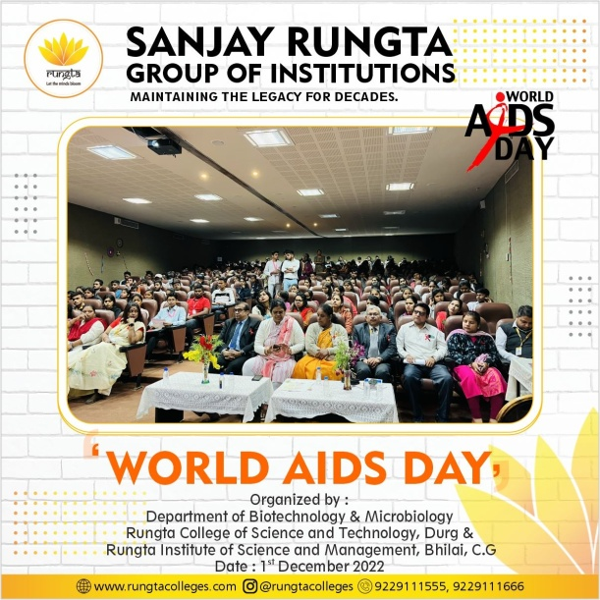

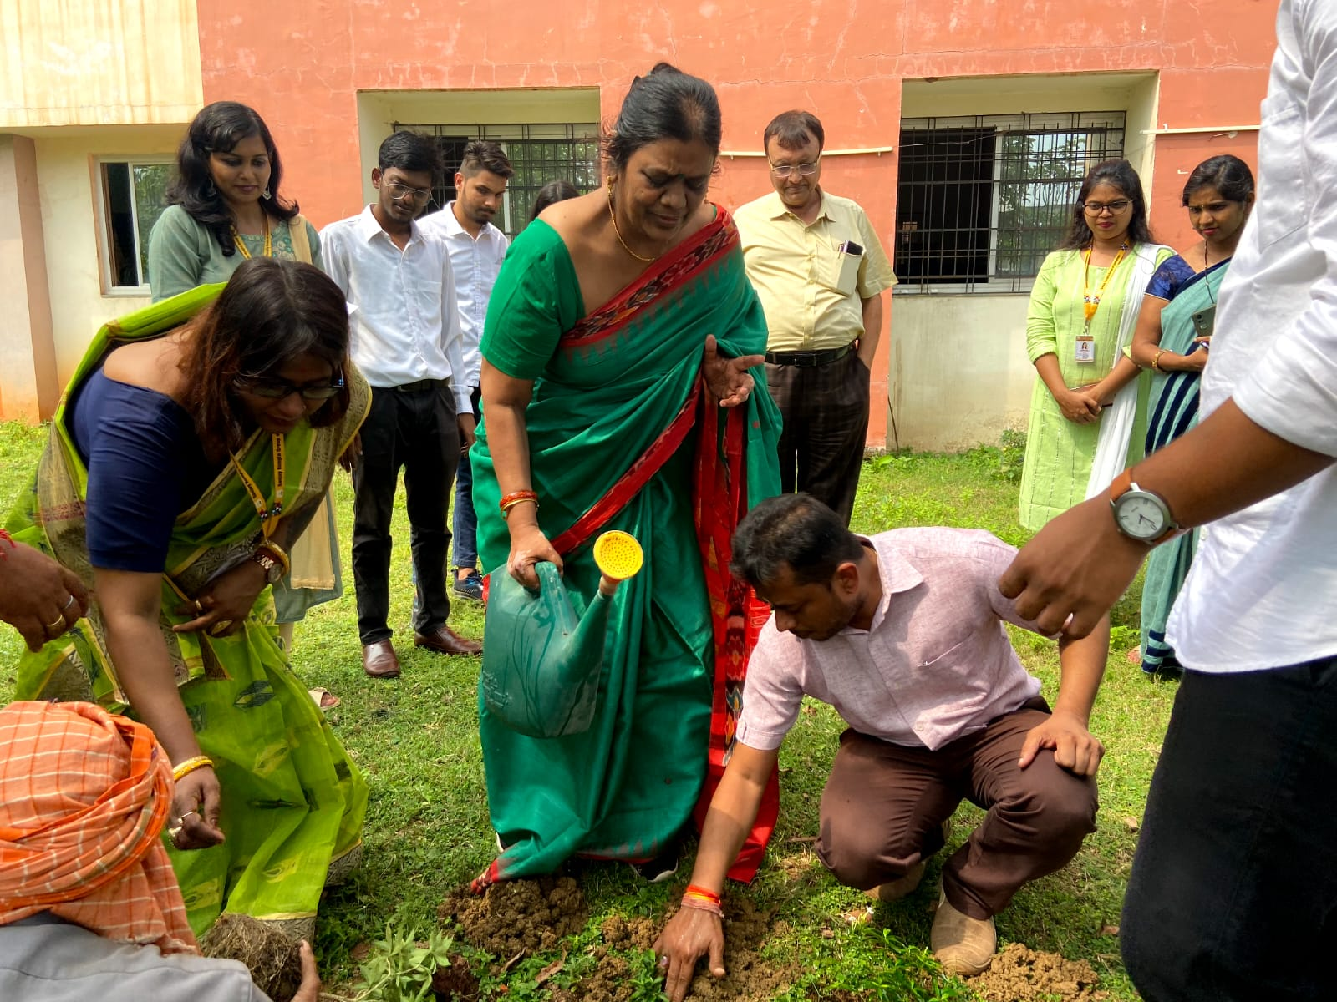
PLANTATION

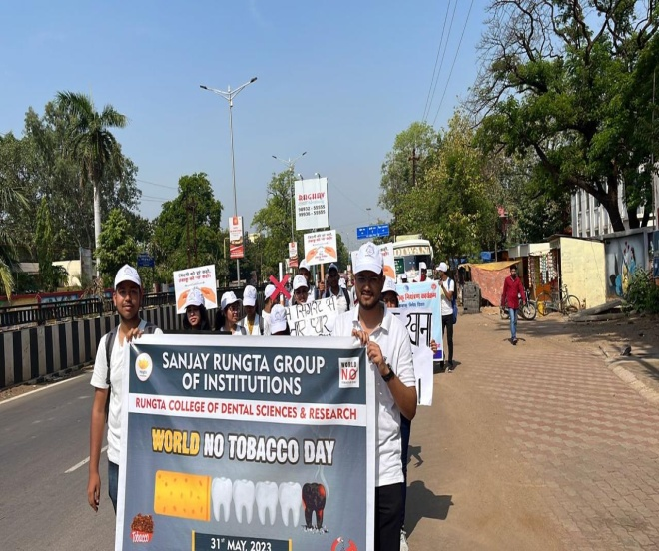
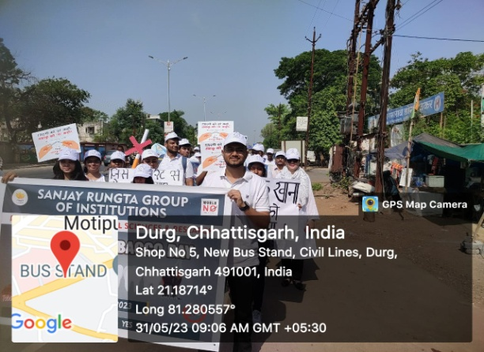
RALLY ON NO TABACCO DAY
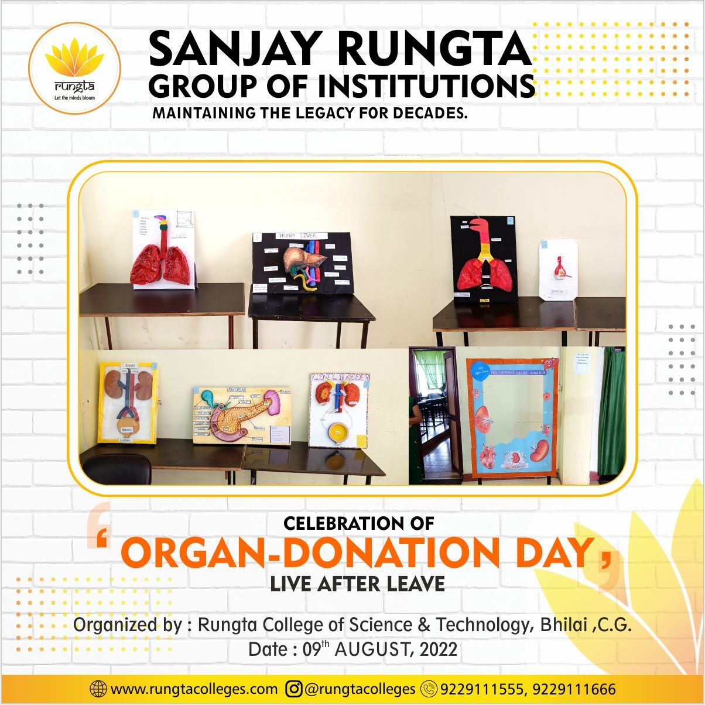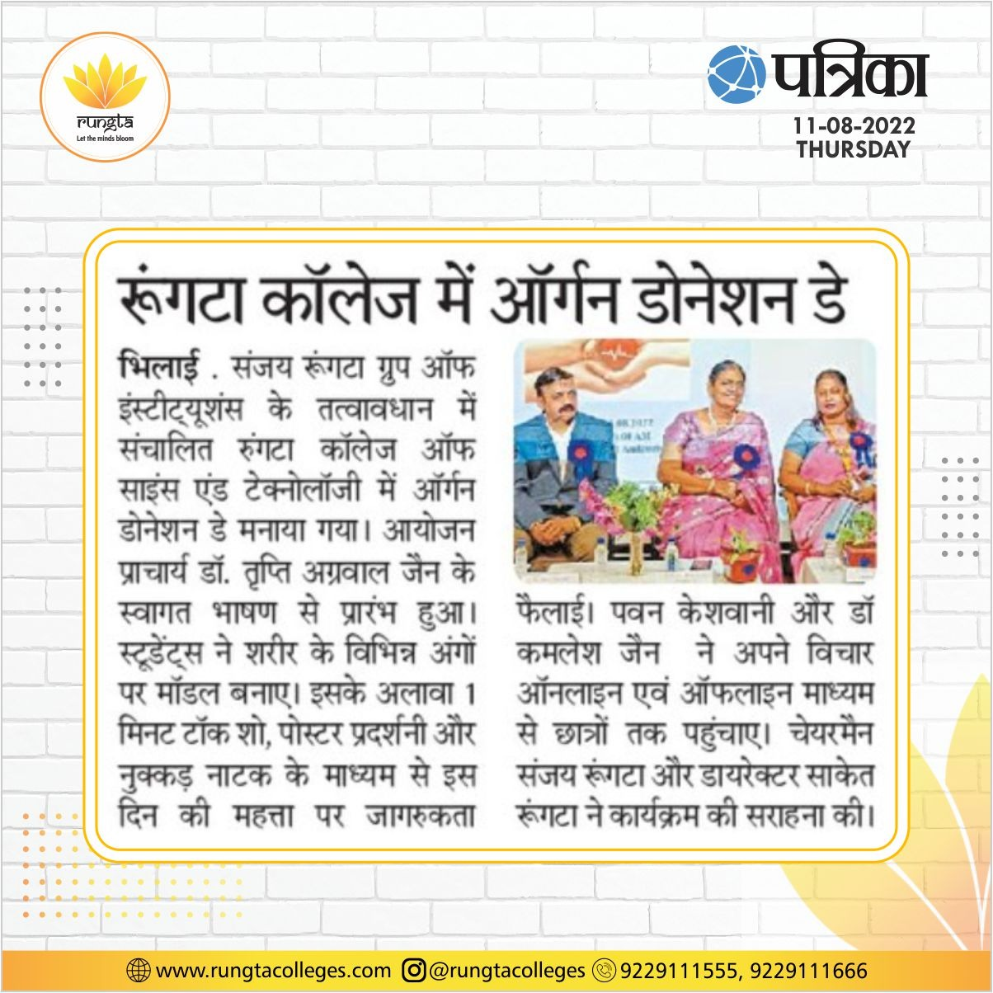
Speaker and in association with Mr. PAWAN KESHWANI
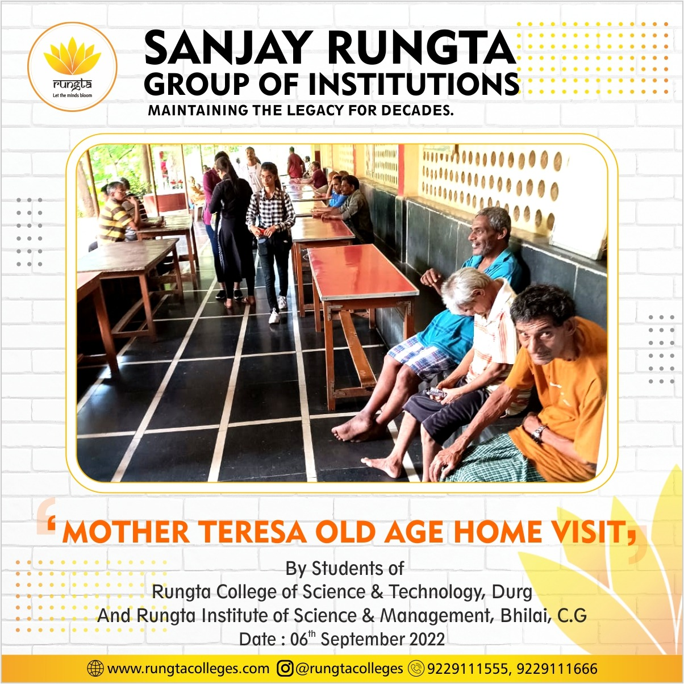
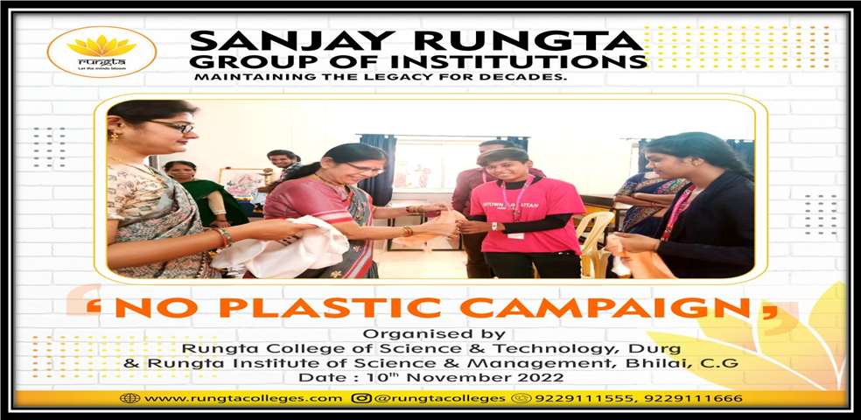

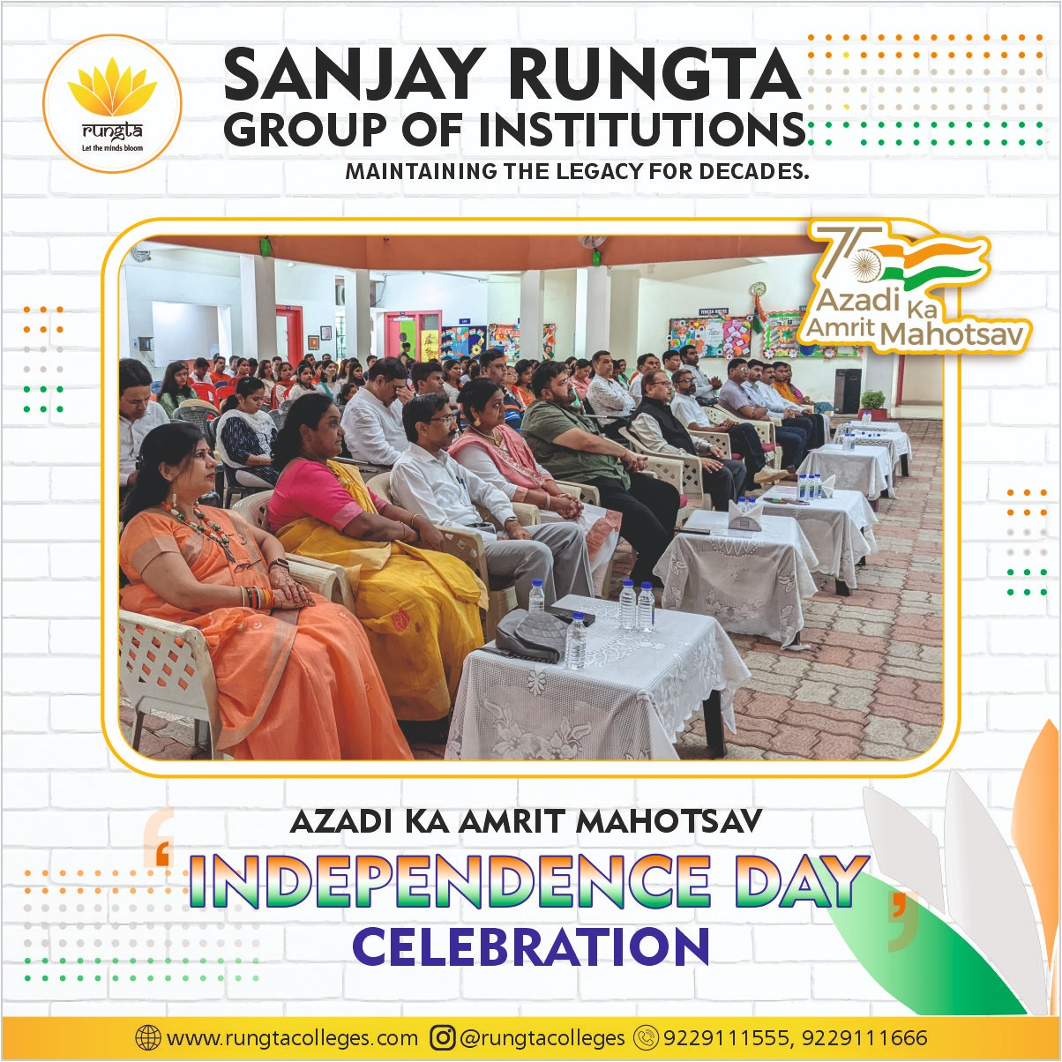
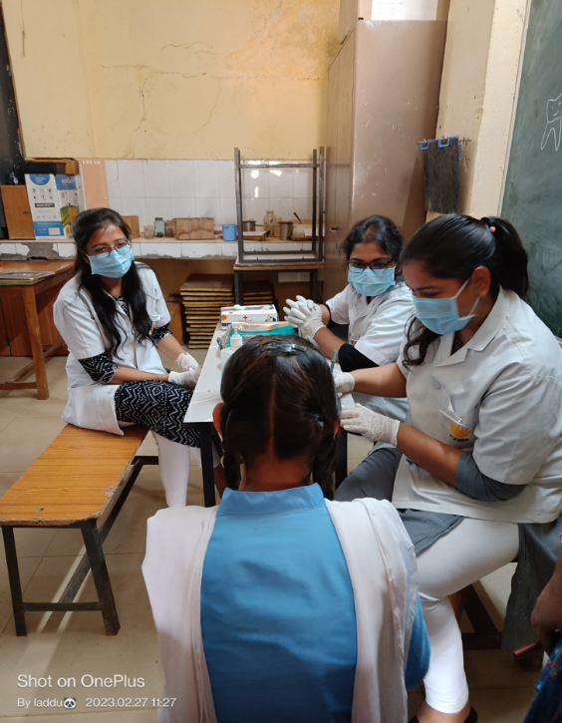
FREE DENTAL CHECKUP AT DHOR VILLAGE AT GOVT SCHOOL

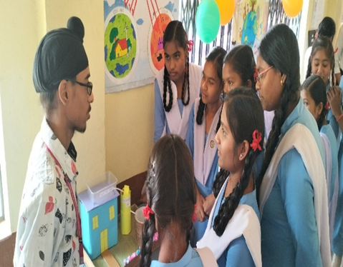
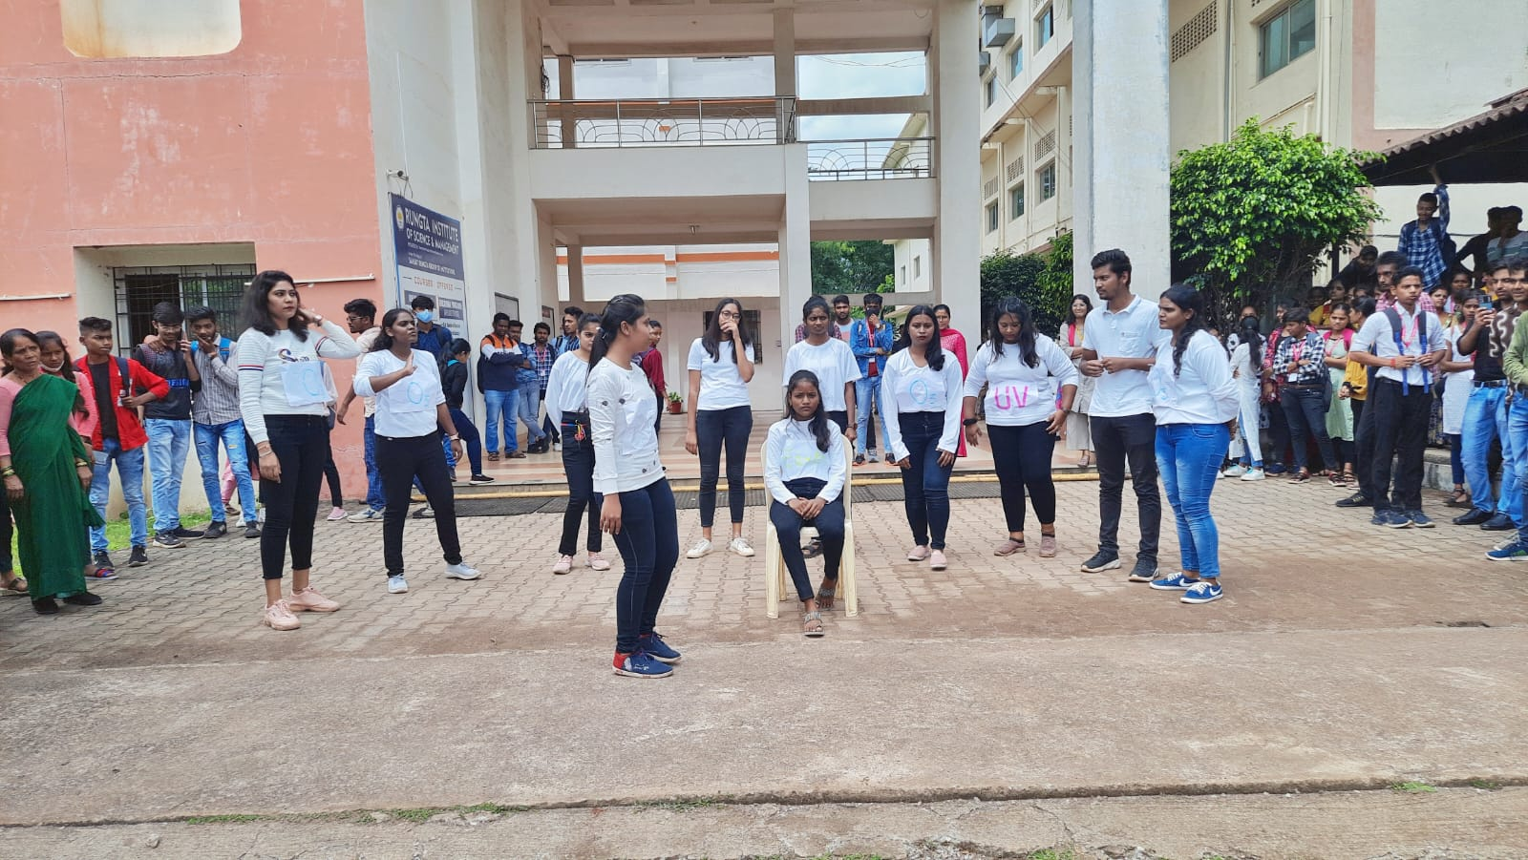

NUKKAD NATAK AND SCIENCE EXHIBITION AT DHOR , GOVT SCHOOL

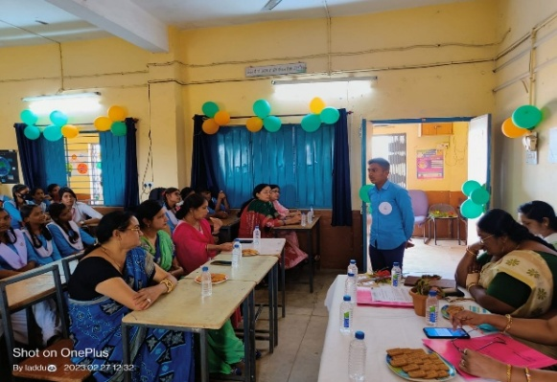
DEBATE AND SPEECH COMPETITION ON GLOBAL WARMING AT GOVT SCHOOL DHOUR

